Interface verification
The image shows the data format previously provided by Techroute :
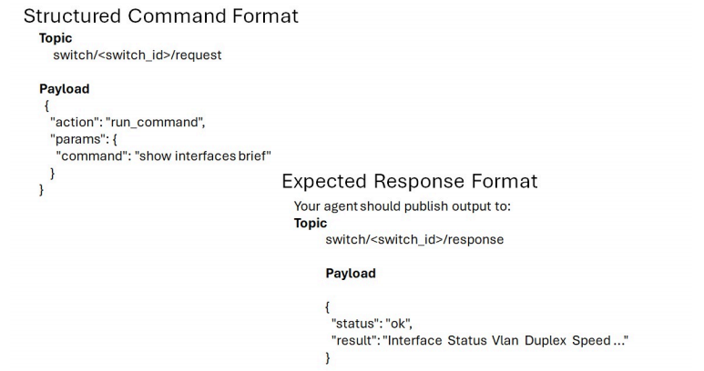

1. Topic format confirmation
The current requirement format is:
- switch/<switch_id>/request
- switch/<switch_id>/response
The following needs to be confirmed:
- switch : Use device SN ?
- Currently, only request and response messages are supported . Will notification messages (such as notify / event messages ) be supported?

2. Command Definition Description
Please supply the specify:
- command basic information:
    - A complete list of commands that support this feature.
    - Clarify whether the command directly corresponds to our existing CLI command, and whether compatibility issues with third-party devices need to be considered.
    - If it corresponds to a CLI command, it is recommended to add command mode.
    - If it doesn't correspond to the CLI command, do we need to add any extra parameters?
- The corresponding response (response/result) definition for the command:
    - Should the data be returned in CLI format, or should the format be specified individually?
A complete data structure description is required to facilitate alignment between the two parties.

3. Status Code Definition
It needs to be clarified that:
- What are the possible values for status?
- Return value definition on failure
- Error message field format (e.g., error_msg)

4. Request/Response Association Mechanism
The mapping between request and response is currently undefined. This presents a potential risk: under concurrent requests or network fluctuations, responses may be returned out of order, leading to a mismatch between requests and responses.
We suggest you confirm whether to add one of the following fields:
- sequence
- request_id
- transaction_id
This enhances message relevance and avoids matching ambiguity.

Acceptance Arrangements

1. Testing environment support
Please supply the availability of support for the testing environment.
- Can you provide a complete testing environment and support remote debugging?

If a remote testing environment cannot be provided, the following collaboration methods are recommended:
- We provide phased versions to the customer;
- The customer is conducting tests on-site;
- The client outputs a test report, and both parties align and confirm the report.

